**CIRT PSEUDO-COMPONENT DIAGRAM**

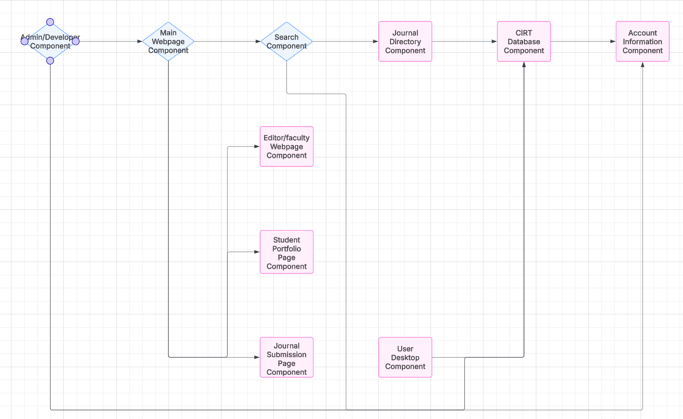

**MAJOR COMPONENTS:**

CIRT Database, searching component, main webpage and subsequent pages for student portfolios, editors/faculty, and finalized journal submission page. Developer component to fix any overall errors/bugs in the website.

**SUMMARY (How they connect):**

* **Admin/Developer component has access to every other component of website for any bug fixes required.**
* **CIRT Database is connected with Journal Directory, Account Information, User Desktop, and the Main Webpage.**
* **Search component connects above components together with database for traversal of information from database.**
* **Subpages of main website component connected solely to main website for more centralized traversal of data from database (may be modified if too complex, tbd).**
* **Journal directory component directly in tandem with searching component, arguably one of the most vital components as it is an academic journal archive.**
* **Account information, acquired through users creating an account, connected also to main database for centralized processing.**
* **Overall, we may or may not break apart main CIRT database into smaller sub-databases, tbd.**